**2025 Community Bank Bungendore Show**

**Sunday 26 October**

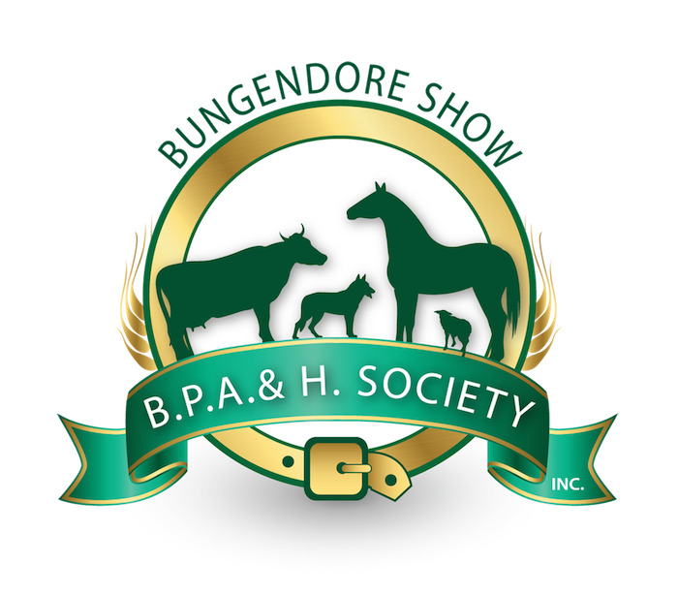

**Cattle Schedule**

PIC: NE083239 (Bungendore Racecourse Showground Trust)

Chief Steward: Sarah Abigail

Contact: cattle@bungendoreshow.com.au

**Thank you to our generous sponsors for the Cattle Competitions:**

**Gold sponsor:**

**Other sponsors:**

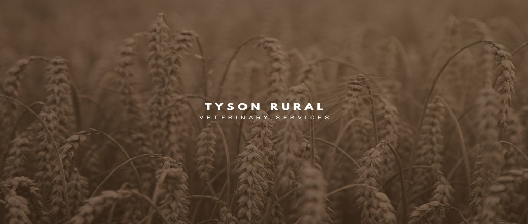

**Special thanks to the following people for their support in 2025:**

Tony Starr

Alexa Furphy

Christine Collins

Daryl Holder

Dr Katie Asplin

Matthew Smee

Olivia Jennings

|  |  |  |  |
| --- | --- | --- | --- |
| HEALTH DECLARATIONS: Exhibitors MUST complete the National Cattle Health Declaration (V: 24/10/22), and submit the form along with Pestivirus results, with entries, to be received by the Cattle Section by Sunday 19 October 2025. Entries submitted without a valid health declaration will not be accepted. | | | |
| NLIS Tagging: All cattle must possess a National Livestock Identification System (NLIS) device such as an NLIS approved electronic ear tag. | | | |
| STOCK MOVEMENT AND IDENTIFICATION: All stock must comply with NSW legislation in relation to animal movements and stock identification. Any stock found in breach of these  requirements may be excluded from competition and requested to leave the grounds. Any costs relating to a breach issue are the responsibility of the exhibitor. | | | |
| AGE AND DATE OF BIRTH: 1 November 2025 is the reference date for the calculation of age of an animal for the purposes of entering age classes in the 2025 Bungendore Show Cattle Schedule. | | | |
| ENTRY FEES: $5 per class per exhibit  Stock to arrive by 9am, judging to commence at approximately 9.30am | | | |
| STRAW: Competitors to supply their own straw and bedding. There may be a small supply of straw available to purchase on the day, but competitors are advised to check social media or contact the Chief Cattle Steward to check whether straw becomes available. Bedding and manure must be cleaned out of shed bays and from any other areas in which you mobilise your cattle before departure and left in the dedicated manure pile as directed. A $50 stall cleaning fee will be charged to competitors who do not remove bedding and manure from stalls. | | | |
| ANY OTHER BREED, BRITISH & EUROPEAN (including Bos Indicus) TO BE JUDGED SEPARATELY  NOTE: Classes may be re-grouped in any way at the discretion of the Chief Steward, including combining any other breed, British and European. Ribbons to 3rd place, Broad Ribbons to Champions and Reserves. Cash Prizes - Classes - 1st TBC, 2nd TBC (at least 3 entries in class). Champion, Supreme and above prizes to be announced. All prizes GST inclusive. | | | |
| MOST SUCCESSFUL EXHIBITOR:  The winner being the highest point scorer out of all breeds. No additional points for Champions and Reserve.  Point Scores: 1st = 5, 2nd = 3, 3rd = 1 | | | |
| **JUDGE** | | Tony Starr – 0427 833 562 | |
| **CHIEF STEWARD** | | Sarah Abigail 0456 004 005 | |
| **STEWARDS** | | Matthew Smee, Olivia Jennings | |
| **ENTRIES CLOSE** | | 19 October 2025 | |
| **LATE ENTRIES** | | Sarah Abigail 0456 004 005 | |
| **ENTRIES VIA** | | All entries must be submitted via Showday – link will be available via the show website www.bungendoreshow.com.au | |
| **PRIZES** | | TBC | |
| **CATTLE CLASSES** | | | |
| **JUNIOR BULL** - note classes, including champion, may be combined | | | |
| 15001 | British Bull 9-12 months | 15004 | *European Bull 9-12 months* |
| 15002 | *British Bull 12-16 months* | 15005 | *European Bull 12-16 months* |
| 15007 | *Any other breed Bull 9-12 months* | 15008 | *Any other breed Bull 12-16 months* |
| 15009 | *Any other breed Bull 16-20 months* |  |  |
|  | | | |
| **SENIOR BULL** - note classes, including champion, may be combined | | | |
| 15010 | *British Bull over 20 months* | 15011 | *European Bull over 20 months* |
| 15012 | *Any other breed Bull over 20 months* |  |  |
|  | |  | |
| Champion British Bull (including junior bull) *Prize:* | | Reserve Champion British Bull (including junior bull) *Prize:* | |
| Champion European Bull (including junior bull) *Prize:* | | Reserve Champion European Bull (including junior bull) *Prize:* | |
| Champion Any other breed Bull (including junior bull) *Prize:* | | Reserve Champion Any other breed Bull (including junior bull) *Prize:* | |
| Hillview Angus Supreme Bull  Champion Bull (including junior bull) *Prize:* | |  | |
|  | |  | |
| **JUNIOR FEMALE** | | | |
| 15013 | *British Female 9-12 months* | 15016 | *European Female 9-12 months* |
| 15014 | *British Female 12-16 months* | 15017 | *European Female 12-16 months* |
| 15015 | *British Female 16-20 months* | 15018 | *European Female 16-20 months* |
| 15019 | *Any other breed Female 9-12 months* | 15020 | *Any other breed Female 12-16 months* |
| 15021 | *Any other breed Female 16-20 months* |  |  |
|  | |  | |
| **SENIOR FEMALE** | | | |
| 15022 | *British Female over 20 months* | 15023 | *European Female over 20 months* |
| 15024 | *Any other breed Female over 20 months* |  |  |
|  | |  | |
| Champion British Female (including junior female) *Prize:* | | Reserve Champion British Female (including junior female) *Prize:* | |
| Champion European Female (including junior female) *Prize:* | | Reserve Champion European Female (including junior female) *Prize:* | |
| Champion Any other breed Female (including junior female) *Prize:* | | Reserve Champion Any other breed Female (including junior female) *Prize:* | |
| Champion Female (including junior female) *Prize:* | |  | |
|  | |  | |
| **STEERS** | | | |
| 15025 | *Purebred - Lightweight Steer* | 15026 | *Purebred - Heavyweight steer* |
| Champion Steer prize: | | Reserve Champion Steer *Prize:* | |
| Supreme Cattle Exhibit | |  | |
| Most Successful Exhibitor | |  | |
|  | |  | |
| **PARADER CLASSES** Ages as at 26-10-2025 – Paraders judged on presentation & ability to handle & parade animals | | | |
| 15027 | Junior parader - Under 13 years | 15028 | Intermediate parader - 13 - 15 years |
| 15029 | Senior parader - 16 years and over |  |  |
|  | |  | |
| Trassoc Livestock Champion Junior Parader  *Prize: Engraved Trophy* | | Reserve Champion Parader *Prize:* | |
|  | |  | |